Revision History

|  |  |  |  |
| --- | --- | --- | --- |
| **Date** | **Version** | **Description** | **Author** |
| <11/10/2017> | <1.0> | <SDP First Draft> | <Atakan Atamert, Bora Berk Akdeniz, Orkun Doğan, Oğulcan Cingiler, Sami Menteş > |
|  |  |  |  |
|  |  |  |  |
|  |  |  |  |

**TABLE OF CONTENTS**

Revision History 1

1 Identification 3

1.1 Document overview 3

1.2 Abbreviations 3

1.2.1 Abbreviations 3

1.3 References 3

1.3.1 Project References 3

2 Software Development Activities 3

2.1 Software development process 3

2.1.1 Overview of process phases 3

2.1.2 Technical documentation 4

2.1.3 Deliverables 4

2.2 Software development tools 4

2.2.1 Workstation 4

2.2.2 Requirements management and documentation 4

2.2.3 Software Design 4

2.2.4 Coding and automated tests 4

2.2.5 Configuration management 4

2.3 Software development rules and standards 4

3 Responsibilities 5

3.1 Activities and responsibilities 5

4 Risk Assessment 5

4.1 Risk Analysis 5

4.2 Risk Planning 5

# Identification

## Document overview

This document contains the software development plan of software Shoot Shoot! Shoot Shoot! will be a first person shooter (FPS) game software that will simulate an arena sort of shooter game. (NEEDS REVISION) This software will primarily be made for Desktop systems as an application, later on during its development this decision might be subject to change as there are other mobile platforms that needs to be considered.

## Abbreviations

### Abbreviations

Shoot Shoot!: <The name of the software system to be developed>

UML: Unified Modeling Language

IDE: Integrated Development Environment

SRS: Software Requirement Specification

STP: Software Test Plan

SDD: Software Design Document

STR: Software Test Report

UE4: Unreal Engine 4

BDR: Blender

UDK: Unreal Development Kit

VS: Visual Studio 2017

FPS: First Person Shooter

CMU: Carnegie Mellon University

PS: Photoshop

## References

### Project References

| # | Document Identifier | Document Title |
| --- | --- | --- |
|  |  |  |

# Software Development Activities

The section lists and describes the software development activities of Shoot Shoot! software development project.

## Software development process

This is a course project, which adopts the waterfall model as the software development process.

### Overview of process phases

The software development process for the project will be composed of the following phases:

* Planning
* Requirements Analysis
* Design
* Implementation
* Testing

These phases will follow each other sequentially, where each phase starts just after the completion of the previous one. The following Gantt chart depicts the planned start date and duration for the phases.

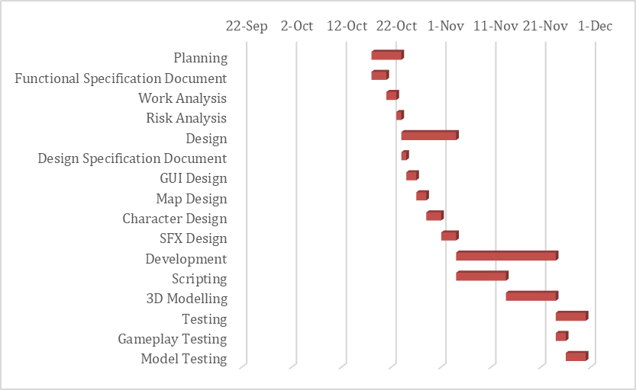

### Technical documentation

The following documentation is produced during the software development phases:

* Software specification: SRS, STP
* Software detailed conception: SDD
* Software tests phases : STR

### Deliverables

The following items will be delivered at the end of the process:

* Technical documentation as outlined in Section 2.1.2
* Software and its configuration files

## Software development tools

### Workstation

Atakan Atamert – Intel Pentium G3258 5.5 GHz-GTX 1060-16GB DDR3 RAM

Sami Menteş – MSI 60QE Apache – Intel i7- 16GB RAM – GTX 960M

Oğulcan Cingiler – Intel i5 – GTX940M – 6GB RAM

Bora Berk Akdeniz – Intel CPU – GTX 970 – 16GB RAM

Orkun Doğan – Intel Core i7–4700MQ CPU 2.4 GHz (3.2 GHz Turbo Boost) – 2x GT755M (SLI) – 16 GB RAM

### Requirements management and documentation

Microsoft Word, Gantt Project

### Software Design

Microsoft Visio

### Coding and automated tests

Microsoft Visual Studio 2017 will be used for scripting purposes in the development phase.

For creating the visual aspects of the FPS game, such as the scenery of the arena, which includes the levels of the arena meaning different maps, the interaction of the player with the AI … (fill this place up) will be made using the Unreal Engine 4 (v. 4.17.2, version is subject to change as the owner updates the engine software). As for the scripts, which will be used to make this scenery work as a first person shooter game, they will be written in C++ language.

As for the 3D modelling phase, a software called Blender (v. 2.79, version is subject to change as the owner updates this piece of software) will be used. The assets created here will be used while making the designs in UE4.

Photoshop will be used for creating the textures of the objects, which are going to be used in the UE4 engine.

The library we will mainly be using for scripting is the UE4 internal library.

### Configuration management

GitHub[1] will be used for software configuration management and tracking issues regarding the software development. A public repository will be created for this purpose.

## Software development rules and standards

UML[2] will be used while preparing the software design documentation.

CMU C++ Coding Standards

CMU C++ Coding Standards will be used for scripting in the Unity Engine 4 by using Visual Studio 2017 during the scripting phase of the development process.

# Responsibilities

## Activities and responsibilities

|  |  |  |
| --- | --- | --- |
| **Activity** | **Responsibility** | **Comment** |
| Project management | AtakanAtamert-Orkun Doğan |  |
| Configuration tools management | Orkun Doğan |  |
| Script Management | Bora Berk Akdeniz, Oğulcan Cingiler, Sami Menteş, Orkun Doğan |  |
| Software specifications | Atakan Atamert, Bora Berk Akdeniz, Orkun Doğan, Oğulcan Cingiler, Sami Menteş |  |
| 3D Modelling | Atakan Atamert |  |
| Controller Management | Bora Berk Akdeniz, Orkun Doğan, Oğulcan Cingiler, Sami Menteş |  |

# Risk Assessment

## Risk Analysis

|  |  |  |
| --- | --- | --- |
| **Risk** | **Probability** | **Effects** |
| The time required to develop the software is  underestimated | High | Serious |
| Required training for staff is not available | High | Serious |
| The size of the software is underestimated | High | Serious |
| A group member can not be able to work | Moderate | Tolerable |
| Workstation problems can occur | Low | Tolerable |

## Risk Planning

|  |  |
| --- | --- |
| **Risk** | **Strategy** |
| Underestimate develop time | Increase worktime |
| Training insufficient | Increase training volume |
| Underestimated software size | Decrease functionalities |
| Missing staff member | Redistribute workload |
| Workstation problems | Increase workload and repair |

1. http://www.github.com
2. http://www.uml.org/